Printer Model in Blender Environment

Axis X&Y&Z

Z
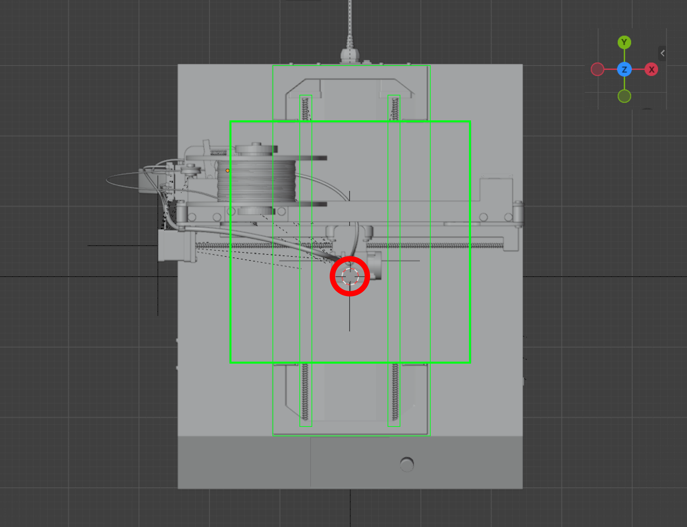
Full Assembly View
This image shows the printer with most of its mechanical components visible.
- Central Focus: The red circle highlights the 3D Cursor, which is currently centered on the nozzle/hotend assembly.
- Green Outlines: These indicate that several objects are selected simultaneously, likely including the Y-axis rails and the bed plate.
- Visible Components: You can see the filament spool (top left), the X-axis gantry, the extruder motor, and the underlying frame and wiring.
- Perspective: Looking down from the Top (+Z) axis.

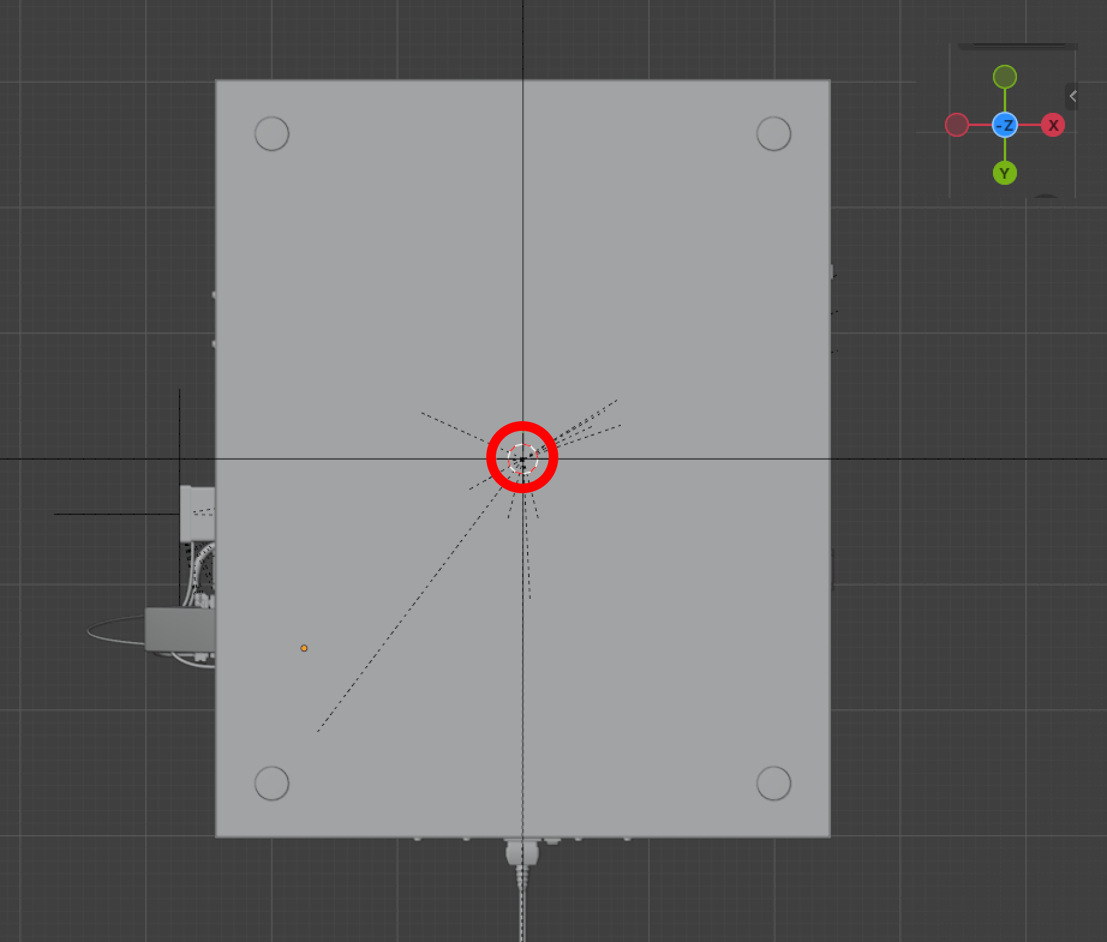
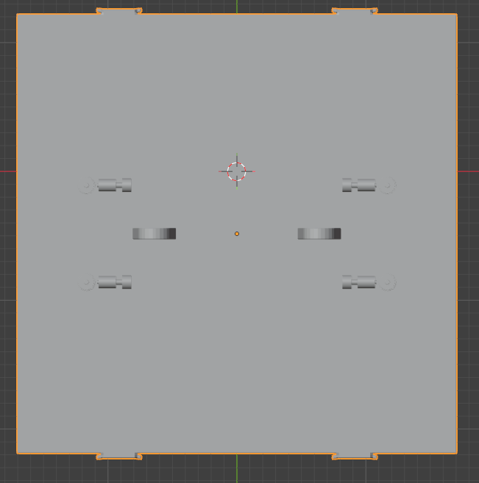

X
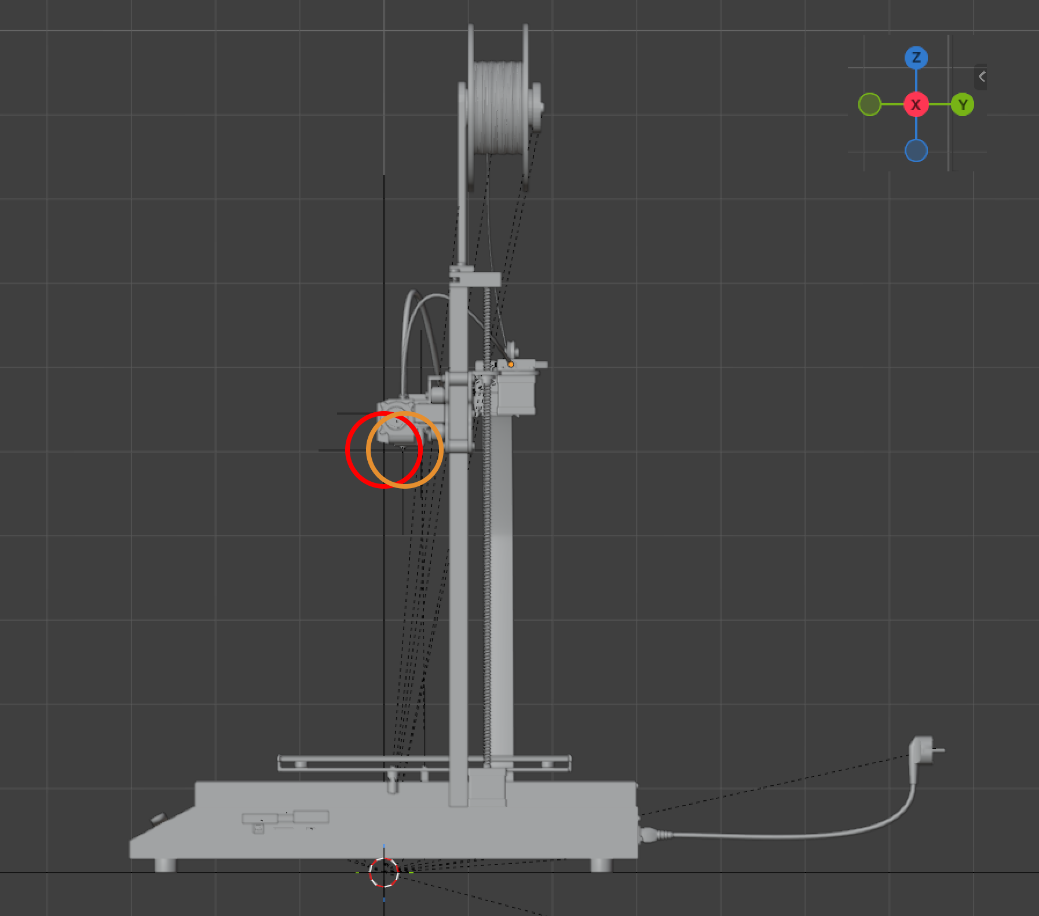
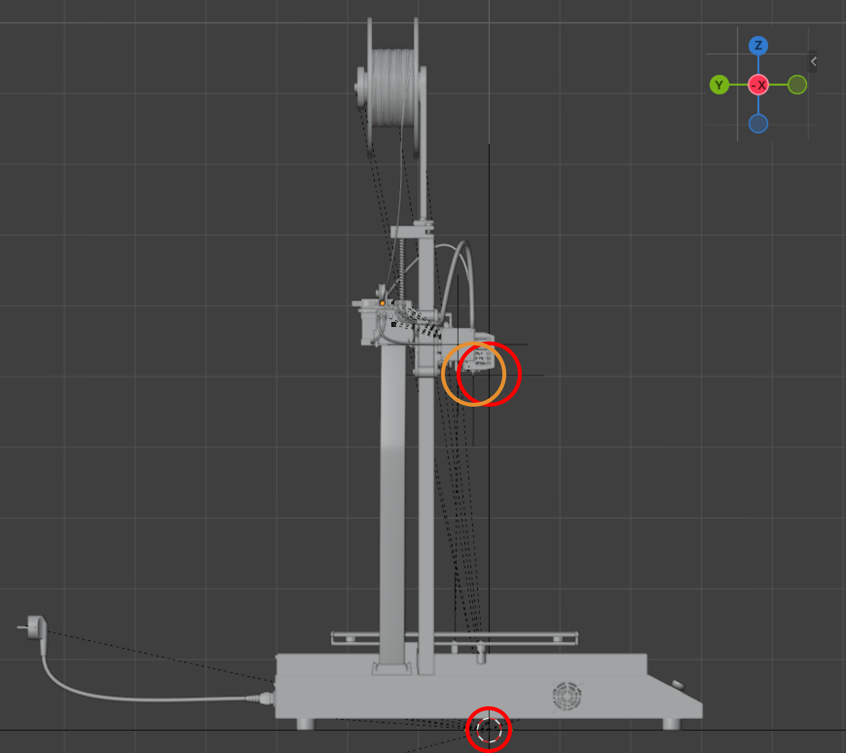

Y
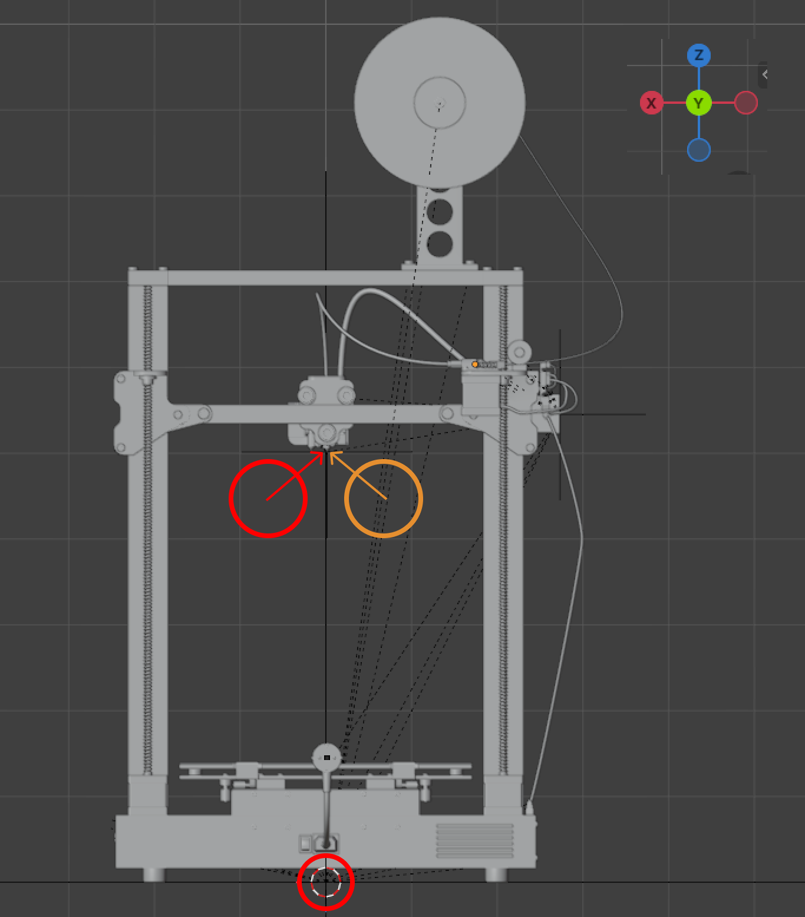
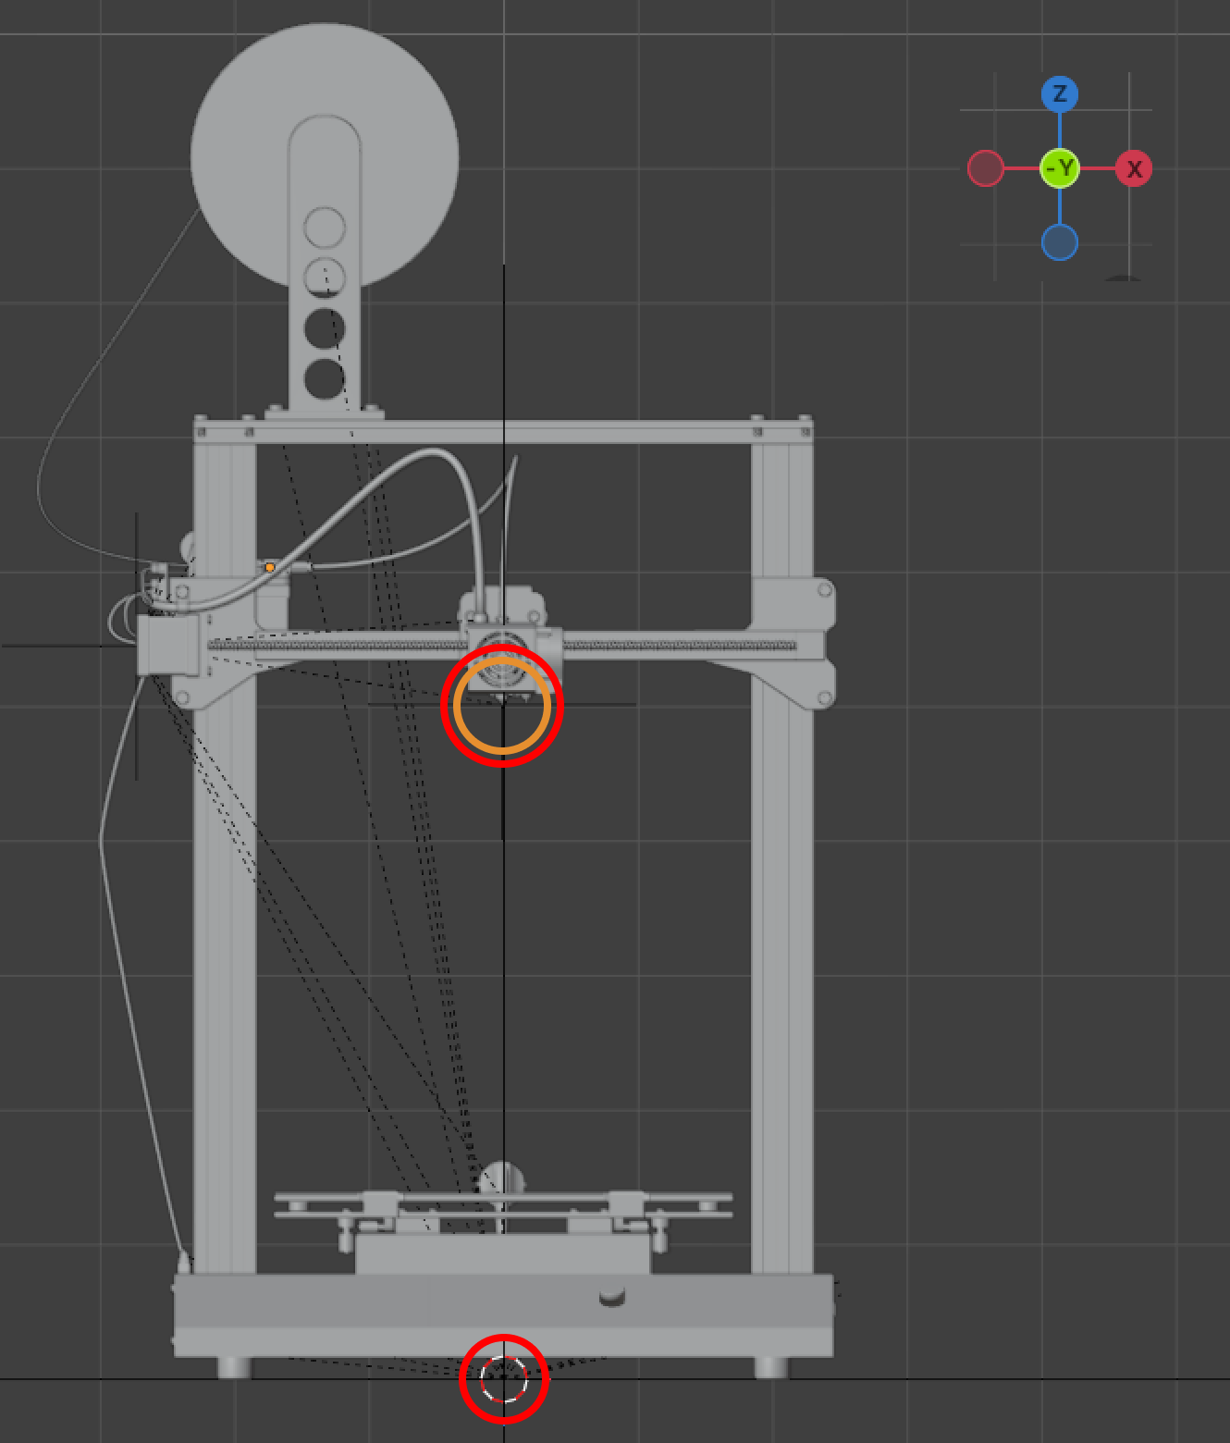

Issue
In the imported 3D printer model, certain components such as the Tisch (print bed) and the Druckkopf (nozzle / print head) are not aligned with the Three.js world origin (X=0, Y=0).
Specifically:
- Tisch (bed)
  - Almost centered on the Y axis (Y ≈ 0)
  - Not centered on the X axis
- Druckkopf (nozzle)
  - Not centered on X
  - Not centered on Y
Because of this misalignment, the printer components do not correspond correctly to the Three.js world coordinate system, which makes it difficult to simulate printer movements accurately.

Solution
To correctly position the printer components in the Three.js scene, the following steps should be performed.
1. Identify the Three.js World Coordinate System
In Three.js, the world origin is typically:
(0, 0, 0)
Where:
- X → horizontal axis
- Y → vertical axis
- Z → depth axis
This origin should represent the reference point of the printer environment.
2. Load and Prepare the 3D Model
After loading the .glb model in Three.js, several adjustments may be required, such as:
- Scaling the model
- Adjusting materials or colors
- Repositioning specific components
These adjustments are necessary because the model was originally created in Blender, which may use:
- Different unit scales
- Different coordinate origins
3. Handle Unit Conversion
There are two coordinate environments involved:
- Blender model space
- Three.js world space
Since both environments may use different units (meters, millimeters, etc.), a conversion factor may be required to ensure that the printer dimensions remain accurate.
4. Understand Model Local Axes
Inside the .glb model, each object has its own local coordinate system:
- Local X
- Local Y
- Local Z
These axes belong to the model itself, not to the Three.js world.
Therefore, object positions are defined relative to their parent objects, not necessarily relative to the Three.js origin.
5. Determine Default Positions of Key Components
To correctly simulate printer motion, we must determine the default positions of key components:
- Tisch (print bed)
- Druckkopf (print head)
For each component, we should compute:
- The center position (X, Y, Z)
- The reference corner of the bed
For example:
- The Druckkopf may be aligned with the model’s X axis where X = 0.
- The Tisch center may not coincide with the world origin.
6. Define a Reference Corner for the Bed
To properly simulate printing coordinates, we must define a reference corner of the bed.
A practical assumption is:
- The bottom-left corner of the bed is the printer's (0,0) position.
From this reference point:
- The bed center
- The nozzle position
- All print movements
can be calculated consistently.
7. Align Model Components with the World System
Finally:
- Translate the Tisch so its reference position matches the intended world coordinate.
- Adjust the Druckkopf position relative to the bed.
- Ensure that printer movements (X/Y) correspond to real printer coordinates.
When Printing starts, the nozzle set his position where to print and bed moves when it’s necessary depending on g-code. [ default set, re-position , start printing ]

3D Models

G-code
G-code is the machine control language used to instruct CNC machines and 3D printers on how to move and perform operations.
In a 3D printer, G-code tells the printer:
- Where to move the nozzle
- How fast to move
- How much filament to extrude
- When to heat the nozzle or bed
- When to start or stop printing
Each line in a G-code file represents a single instruction executed sequentially by the printer firmware
Structure of a G-code Command
A typical G-code command looks like this:
G1 X50 Y25 Z0.3 F1500 E2
Meaning:
- G1 → move command
- X50 Y25 Z0.3 → target position
- F1500 → movement speed
- E2 → extrude filament
Two Main Types of Commands
1. G Commands (Movement / Geometry)
Command | Meaning
G0 | Rapid movement (move without printing)
G1 | Linear movement (move while extruding)
G28 | Home axes (move to origin)
G90 | Absolute positioning
G91 | Relative positioning
G92 | Set current position

Example:
G28
→ Homes the printer (moves X, Y, Z to their limit switches).
2. M Commands (Machine Settings)
These control hardware functions.
Command | Meaning
M104 | Set nozzle temperature
M109 | Set nozzle temperature and wait
M140 | Set bed temperature
M190 | Set bed temperature and wait
M106 | Turn fan on
M107 | Turn fan off
M84 | Disable motors

In Simulation Context
For Three.js printer simulation, G-code mainly controls:
- X Y Z movement → printer axes
- E → filament extrusion
- F → movement speed
Example:
G1 X100 Y120 Z0.3 F1800
Means in simulation:
- Move nozzle to (100,120,0.3).

Units

Units in Blender
In Blender, the default unit system is meters.
Typical configuration:
- 1 Blender Unit (BU) = 1 meter
However, for mechanical models such as 3D printers, it is common to switch the unit system to millimeters.
Example Blender settings:
- Unit System: Metric
- Unit Scale: 0.001
This means:
1 Blender unit = 1 millimeter
This configuration is recommended for engineering or printer simulations because most printer dimensions are defined in mm.

Units in Three.js
In Three.js, there is no fixed unit system.
Three.js uses abstract units, meaning:
1 unit = whatever scale you decide
For consistency with real-world objects, developers usually define:
1 Three.js unit = 1 meter
or
1 Three.js unit = 1 millimeter
depending on the project.

Units in G-code
G-code is the command language used by most FDM printers running firmware such as Marlin Firmware.
By default, G-code coordinates are expressed in millimeters.
Example :
G1 X100 Y100 Z0.2
Meaning:
- Move nozzle to
X = 100 mm
Y = 100 mm
Z = 0.2 mm
This means that printer movement is directly defined in millimeters.

Simulation
In simulation, the printer model can be small so scaling can be mandatory, adapt configs.
- Before scaling, and after scaling

Bed
The bed dimensions depend on the specific 3D printer model, but most FDM desktop printers use beds around 200–220 mm in X and Y.
Typical 3D Printer Bed Dimensions
Printer Type | Bed Size (X × Y × Z build volume)
Small printers | 120 × 120 × 120 mm
Compact printers | 180 × 180 × 180 mm
Standard desktop printers | 200 × 200 × 200 mm
Most popular size | 220 × 220 × 250 mm
Large printers | 300 × 300 × 400 mm or more

Example: Popular Printer
The very common Creality Ender 3 has:
Bed size (X × Y): 220 mm × 220 mm
Build height (Z): 250 mm
So the printable volume is:
220 mm × 220 mm × 250 mm
For Simulation
a generic FDM printer digital twin, a good default is:
Bed size: 220 mm × 220 mm
Z height: 250 mm
Bed center: X = 110 Y = 110
Bed corners:
Front-left : (0,0)
Front-right : (220,0)
Back-left : (0,220)
Back-right : (220,220)
This aligns perfectly with G-code coordinates.
Those are before Scaling , Scaling is for view

Printed model
model that would be printed in bed must not overpass the dimensions , so to benefit from bed space we suggest to print the center of the model in the center of the bed to do this I suggest :
Get the max length of x of the model and max Y of the model and it recommend to get max Z .
example :
Boat from blender
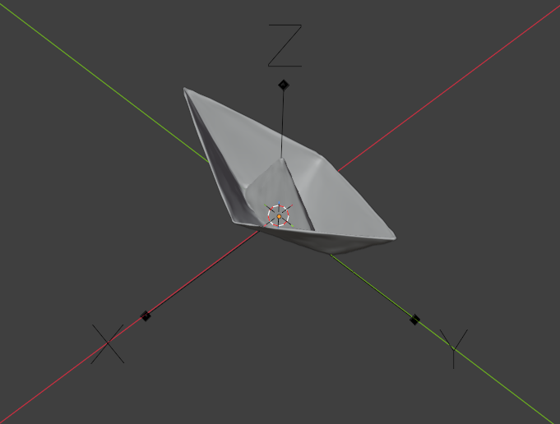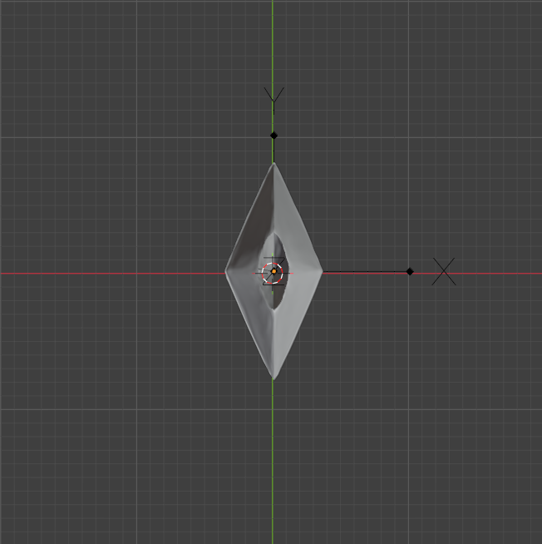
Get dimension , go to three.js , get dimensions of bed and compare (of course with adaptation , if it respects x and y, it’s good ).
Get / calc the center x and y of model and put it in the center of bed as reference
Problem is in G-code how to now the center ?
Well , we need a mechanism or algorithm to calc ,
